Name:_____________________________Period:___________Teacher:___________Date:___________

If you know how to answer a question, or if you can make an educated guess do so. If you do not know how to solve the problem, leave the answer blank.

- Look at each expression, is it equivalent to $\frac{x+3y}{2}$ ?

Circle yes or no for expressions A-D.

$$\frac{4x+3y}{8}$$ | Yes | No
$$\frac{5}{4}\left(\frac{2x+6}{5}\right)$$ | Yes | No
$$\frac{1}{2}\left(x+3y\right)$$ | Yes | No
$$\frac{2}{3}\left(\frac{5x}{6}+\frac{9y}{4}-\frac{x}{12}\right)$$ | Yes | No

- For each linear equation in the table, place a check mark in the box to show whether the equation has no solution, one solution, or infinitely many solutions.

Equation | No Solution | One Solution | Infinitely Many Solutions
$$36x+24=12(x+2+2x)$$
$$x=x+1$$
$$-12\left(x+2\right)=-14x+2$$

- Look at each expression. Is it equivalent to $36x+24y$?

Circle Yes or No for expressions below.

$$6\left(6x+4y\right)$$ | Yes | No
$$30\left(6x-6y\right)$$ | Yes | No
$$12\left(x+2y\right)+2x$$ | Yes | No

- The point on the number line shows the location of $-3\frac{1}{2}$. Label each box with the correct choice found below.

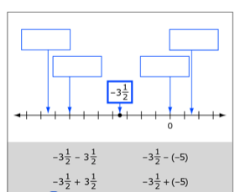
D
C
B
A

- Tony is buying a used car. He will choose between two cars. The table below shows information about each car.

Car | Cost | Miles Per Gallon (MPG) | Estimated Immediate Repairs
Car A | $3,200 | 18 | $700
Car B | $4,700 | 24 | $300

Tony wants to compare the total costs of buying and using these cars.
- Tony estimates he will drive at least 200 miles per month.
- The average cost of gasoline per gallon in his area is $3.70.
- Tony plans on owning the car for 4 years.

Calculate and explain which car will cost Tony the least to buy and use.

Tony should buy Car ________. Explain why this car will cost Tony the least to buy and use.

- A baseball team had $1,000 to spend on supplies. The team spent $185 on a new bat. New baseballs cost $4.00 each. The inequality $185+4b≤1,000$ can be used to determine the number of new baseballs (b) that the team can purchase. Which statement about the number of new baseballs that can be purchased is true?

  - The team can purchase 204 new baseballs.
  - The minimum number of new baseballs that can be purchased is 185.
  - The maximum number of new baseballs that can be purchased is 185.
  - The team can purchase 185 new baseballs, but this number is neither the maximum nor the minimum.

- A restaurant makes a special seasoning for all its grilled vegetables. Here is how the ingredients are mixed:
½ of the mixture is salt
¼ of the mixture is pepper
1/8 of the mixture is garlic powder
1/8 of the mixture is onion powder

The restaurant mixes a 12-cup batch of the mixture every week.
How many cups of each ingredient do they use in the mixture each week?

________Cups salt

________Cups pepper

________Cups garlic powder

________Cups onion powder

8. Jane and Eric are helping their teacher buy supplies for a research project. Every student will get a bag with 2 pencils and 30 index cards.

The teacher gave Jane $17 to buy pencils from the school store. The pencils come in boxes of 12 and cost $1.69 per box.

Eric was given $19 to buy index cards at an office supply store. Index cards are sold in packs of 150 and cost $2.99 per pack.

Jane buys as many boxes of pencils as she can afford. Eric buys as many packages of index cards as he can afford. How many complete bags of supplies can they make?

- Fewer than 10
- Between 10 and 24
- Between 25 and 40
- More than 40

9. Jane and Eric are helping their teacher buy supplies for a research project. Every student will get a bag with 2 pencils and 30 index cards.

The teacher gave Jane $17 to buy pencils from the school store. The pencils come in boxes of 12 and cost $1.69 per box.

Eric was given $19 to buy index cards at an office supply store. Index cards are sold in packs of 150 and cost $2.99 per pack.

Each bag contains 2 pencils and 30 index cards. How much will each bag cost?

Give your answer to the nearest cent. Fill in the blank to complete the sentence.

Each bag of supplies cost _______________ cents to make.

10. Katerina makes patchwork cushions.

She uses right triangles and squares.

She uses triangles along the edges of each cushion, the rest is made from squares.

The backs of the cushions are made of plain material, not patchwork.

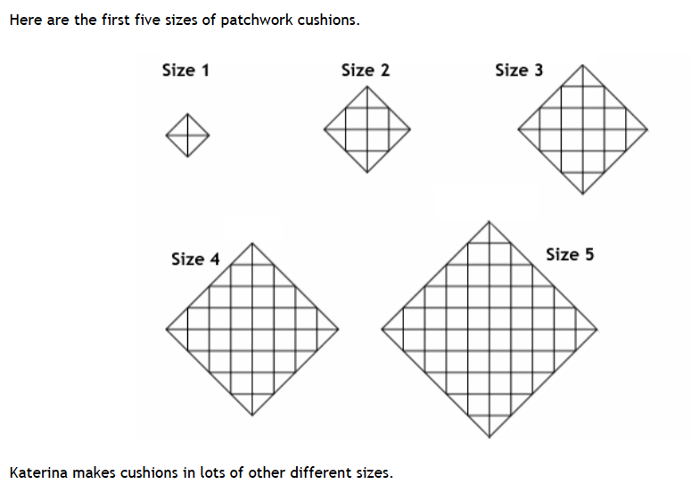

She begins to figure out how many triangles and squares she needs for each size.
For size 1, she needs 4 triangles and 0 squares.
For size 2, she needs 8 triangles and 4 squares.

  - Complete the table to show how many triangles and squares she needs for each of these five sizes.

Size (n) | Number of triangles (t) | Number of squares (s)
1
2
3
4
5

  - Find a rule or a formula that will help Katerina to figure out the number of triangles that she needs for cushions of different sizes. Explain why your rule works.

  - Find a rule or a formula that will help Katerina to figure out the number of squares that she needs for cushions of different sizes. Explain why your rule works.

  - Katerina has a cushion with 180 squares on it. How many triangles are on this cushion? Show your work.

